September 9, 2018

Ana Slocum - S00615504

IT2320 Lab 2

CRN 82936

# Screenshots

### Add new script called myscript.js

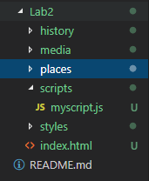

### Add/Remove styles for 3 elements

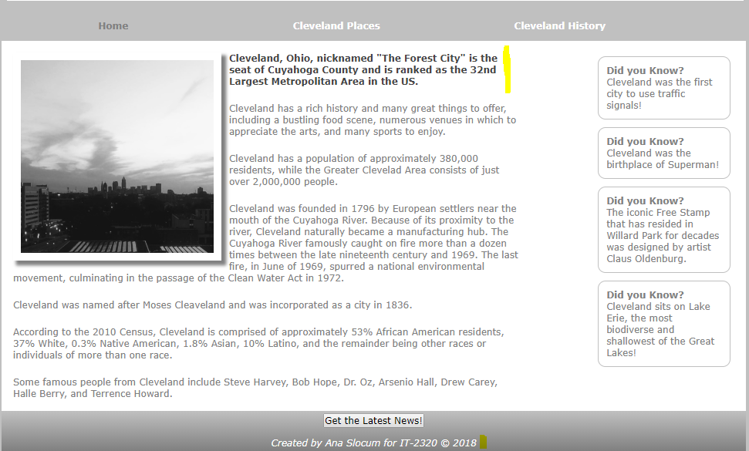

Added Bold/Alternate Color for “p2” Accent Paragraphs

Added Italics for Footer

### Add Array with 3 Different “News” Values and a Button

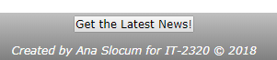

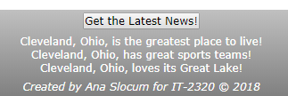

### Additional 1: Copyright Date



### Additional 2: Date Calculation

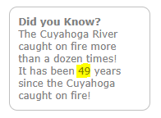



### Additional 3:

### Commit ID